Certification Management system

PREPARED FOR

SFDC Training

Capgemini Technology Services

MENTOR:

Rahul Vikash

PREPARED BY

VOLETI VENKATESH

Abstract:

The Certification Management App is a Salesforce based management App. It basically issues certifications to employees who can request it through App User via Email. The App Admin creates certifications and Vouchers and App User’s Request for Certification is approved by App Admin and a Voucher is automatically assigned to Certification Request once it is Approved.

Scope – Features of system

Following is the functionality provided by the system:

There are two categories of people who would access the system: App User and App Admin.

1.App User :

* Can Create, Edit and Delete Employees
* Can Create, Edit and Delete Certification Requests
* Can view Certifications and Vouchers
* Can view and Edit Reports and Dashboards
* Can Update status of Certification request to Pass or Fail.

2.App Admin:

* Can Create, Edit and Delete Certifications.
* Can Create, Edit and Delete Vouchers.
* Can view Certifications Requests and Employees
* Can view and Edit Reports and Dashboards
* Can Update status of Certification request to Approved or Rejected.

As we mentioned the Scopes of the App, The Out bounds of Scope include:

* The Employees login isn’t included in the Application
* The Employees can share their details and can only see their Approval in mail.
* Third Party applications like email integrations.

Employees Object:

The Employees object is used to have the records related to Employees.

Fields:

|  |
| --- |
| * Emp ID |
| * Emp Name |
| * Primary Skill |
| * Secondary Skill |
| * Experience * Comments * Employee Email |

Certification Object:

The certifications object is used to have records related to Certifications.

Fields:

* Cert Id
* Cert Name
* Comments

Voucher Object:

The Voucher object contains the Voucher ID and other related fields to Vouchers.

Fields:

* Voucher Id
* Voucher Cost
* Certification-Lookup Relationship
* Validity-Date
* Active- Boolean
* Comments

Certification Request Object:

The certification Request Object contains the Vital Relationships with Employees, Vouchers and certifications.

Fields:

* Certification - Master-Detail Relationship
* Employees – Master-Detail Relationship
* Voucher (lookup)
* Due Date
* Status (Picklist)  
   Draft,

Approved

Rejected

Passed

Failed

* Comments

Routing – Process Builder and Approval Process:

Process Builder

It contains a process Builder which contains different stages

* When the status is set to draft it initiates approval process by sending conformation email to employee that the request is submitted.
* Based on Approval ,if the status is Approved the employee and App user gets notified that the request is approved.
* If status is rejected, the comments will be posted along with mail to Employee and App User.
* Once, status is approved a voucher is assigned and status is changed to Assigned.

Approval Process:

* Once the request is submitted and status is draft , an approval process is initiated.
* The Approval is done by App Admin based on details of employee.
* If he/she is approved, the status is changed to Approved as a field update.
* If he/she rejects, the status is changed to rejected as a field Update.

Class Diagram:

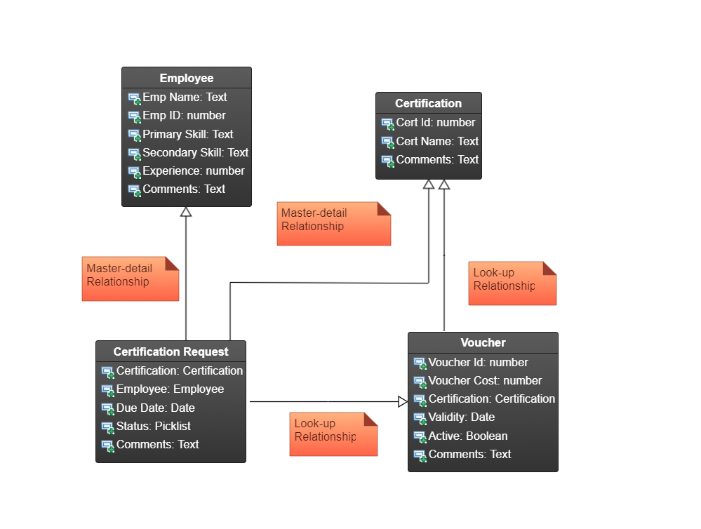

Entity Relationship Diagram:

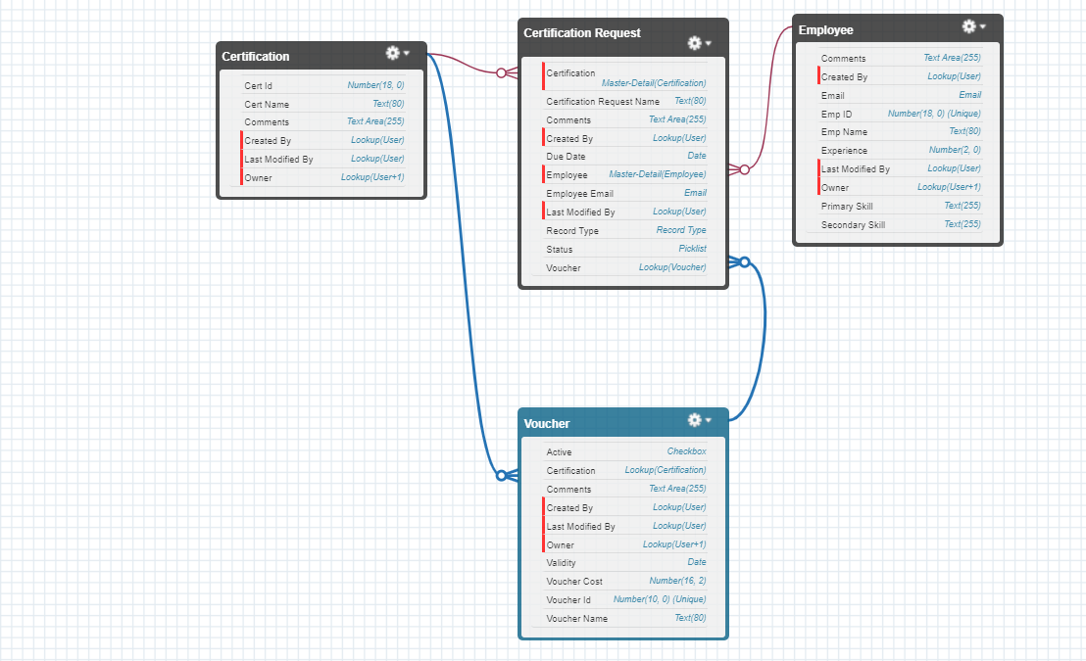

Sequence Diagram of App User:

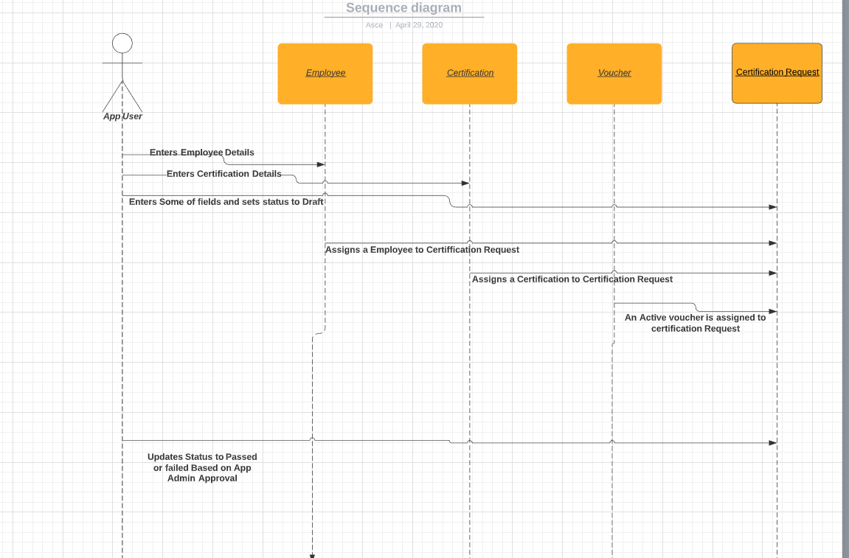

Sequence Diagram of App Admin:

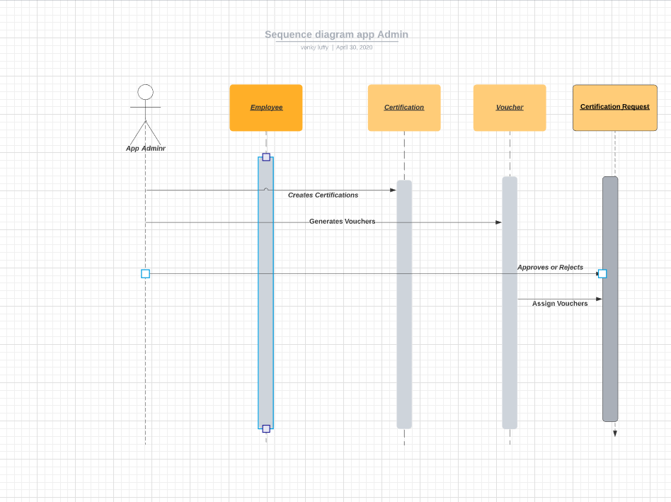

Activity Diagram for App user:

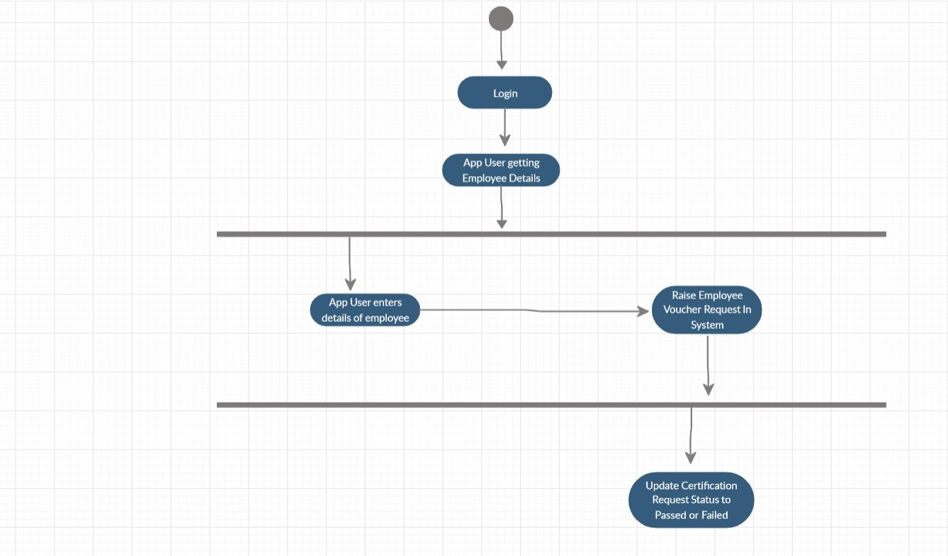

Activity Diagram for App Admin:

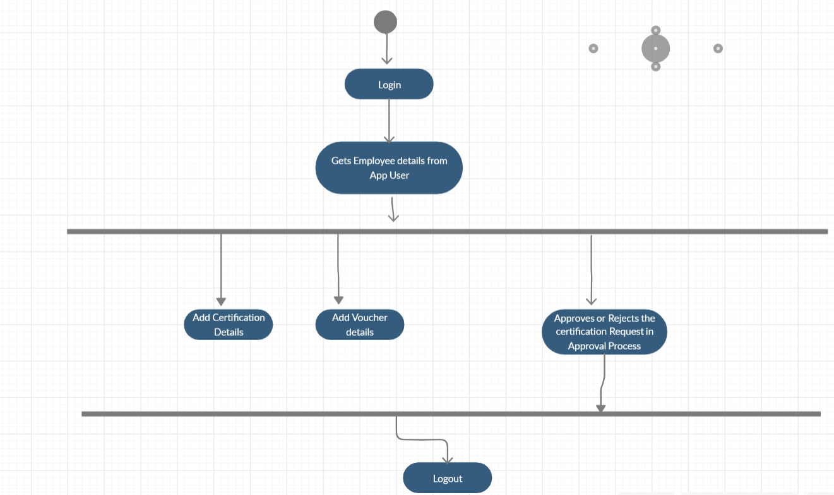

Flow Chart:

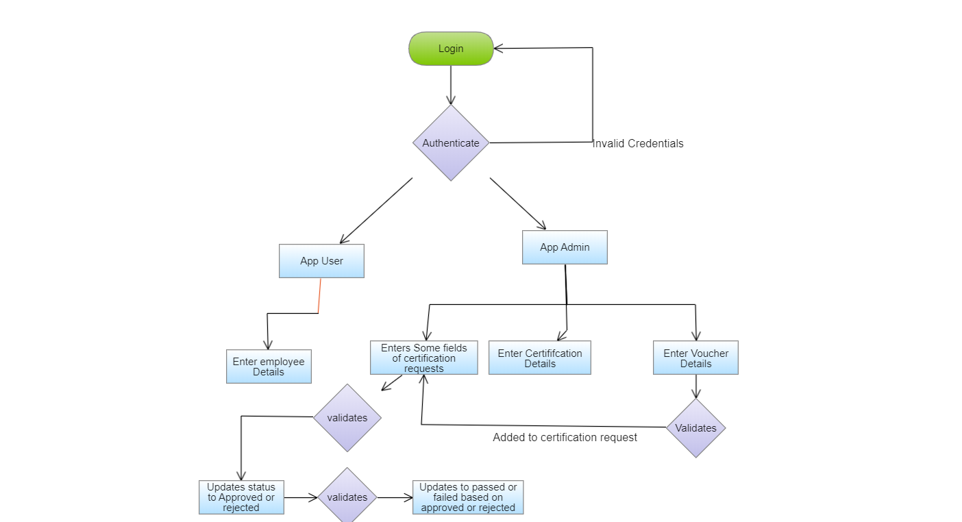

Use Case Diagram:

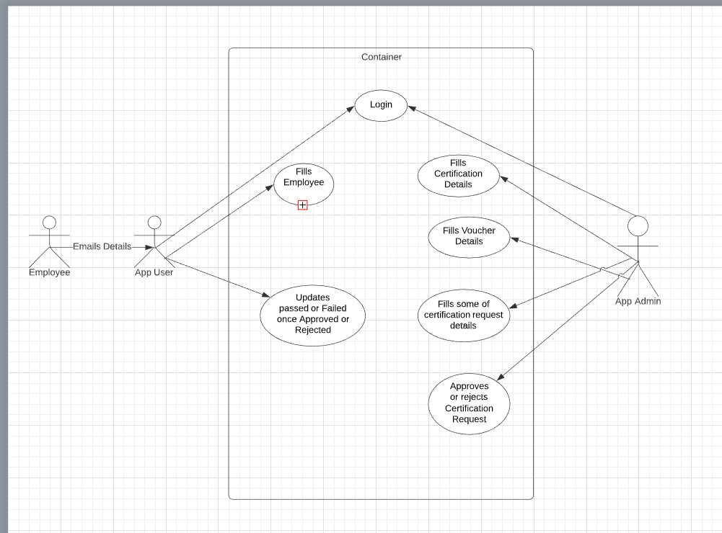

Validations – Rules and triggers

Rules:

The rules here include for the inputs and validations that are to be followed in order to function App smoothly. The rules include:

* The Employee ID must be unique
* Experience must be in years completed
* Certification Name must be unique
* Due Date must not be less than Today.
* Status should always be Draft at the beginning.
* Once an employee has requested for certification, he cannot make any more requests - Same certification and Voucher cannot be used over again, if already used.
* Voucher Name must be unique and 10 chars long.
* Validity should be greater than today.
* A Voucher should be Active for it to be applied.
* If a request has been approved and has no voucher, but a voucher is available, then it should be automatically applied.

Triggers:

The Apex Triggers help in managing the validations and for proper functioning of App. I used 3 Triggers.

1.Checking Duplicates (Certification Request) : This trigger helps us in checking if a Certification request is not being made with the same set of Certification and Voucher details, which were used previously (if any).

2.Employee Duplicate (Certification Request) This trigger helps us in checking if a Certification request is being made with an Employee who already has a request pending or approved.

3.Auto Voucher (Certification Request) This trigger comes into run only when a Request Status has been set to Approved without any voucher for that Request. If a voucher is available in the Voucher object for that certification (unused), then only this trigger will help in applying that voucher to the appropriate Request and deactivate that voucher.

Assumptions:

The Assumptions include:

* Employee sends his information through Email to App User.
* The Employee is not a type of User in Salesforce
* App Admin cannot add App Users.
* Employee cannot modify his details in salesforce.
* Employee request status is passed through Email
* Certification request is assigned to approved by the Approval Process, but not when a voucher has been applied.
* Reports and Dashboards have the time frequency set to the Current Financial Year, and this can be changed be the viewer accordingly, to fit his timeline.

Application Flow:

* App Admin creates Certifications and Vouchers.
* Employees can request to App User through Email.
* App User adds Employees details and raises certification Requests.
* The status of request is draft initially and is sent for approval.
* App Admin Approves or Rejects the request and email notification is sent to App User and employee.
* Once it is Approved and no voucher is added to request, a voucher is automatically assigned to it which is active.
* Employee sends the status of his request passed to him from App Admin to App User
* App User modifies the status of request to Passed or failed.
* The employee cannot apply for certification again once he is passed or failed.
* This is the flow of certification management Application.

New Employees fill Out Form:

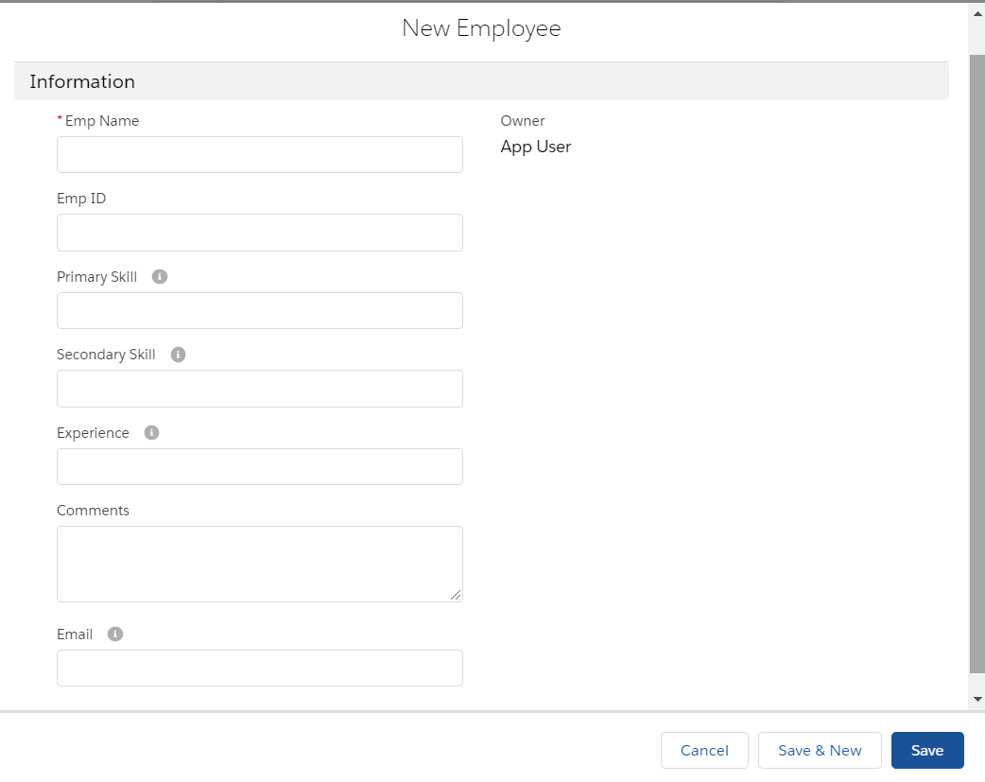

New Certification fill Out Form:

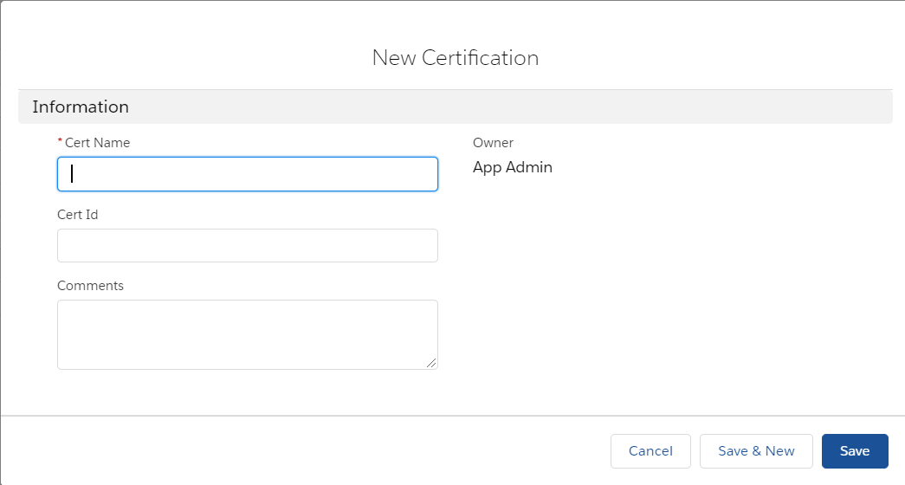

New Voucher fill out form:

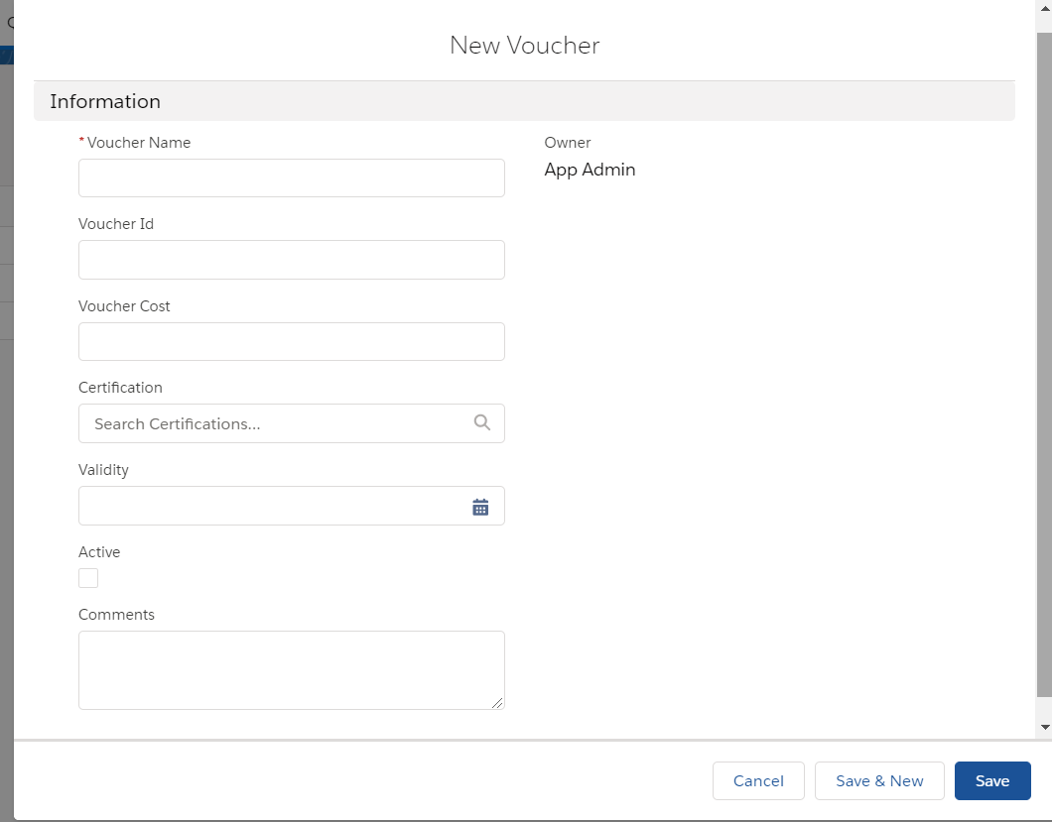

New Certification Request form:

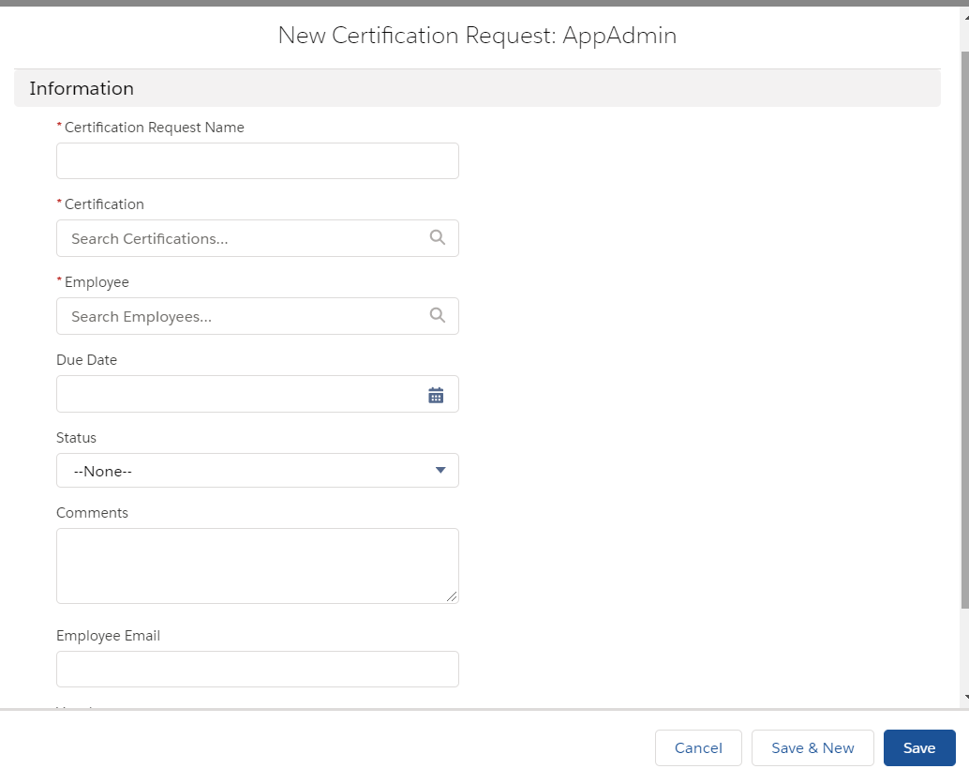

Certification Management System:

Home Page

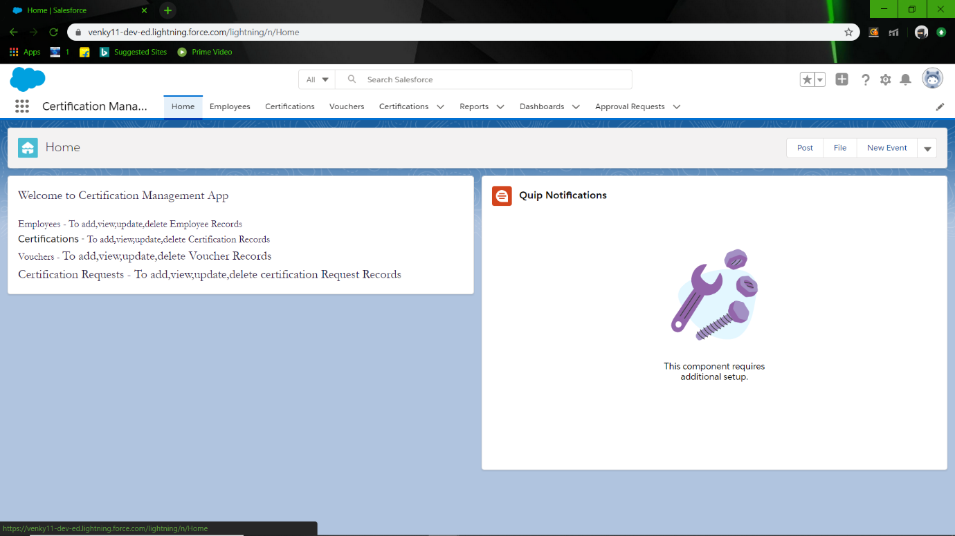

Add Employee

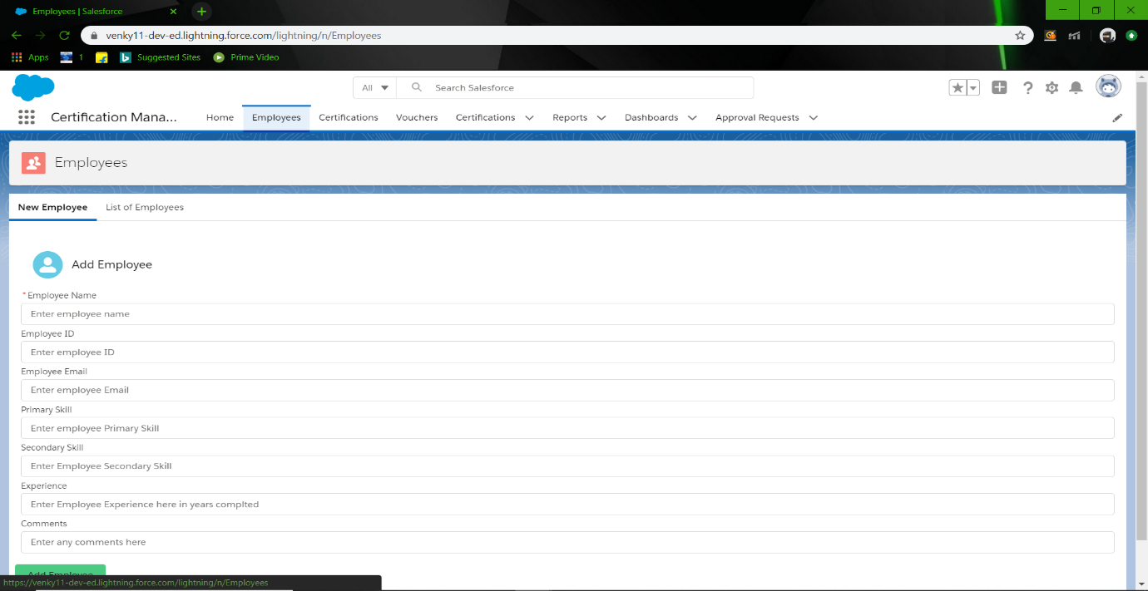

List of employees

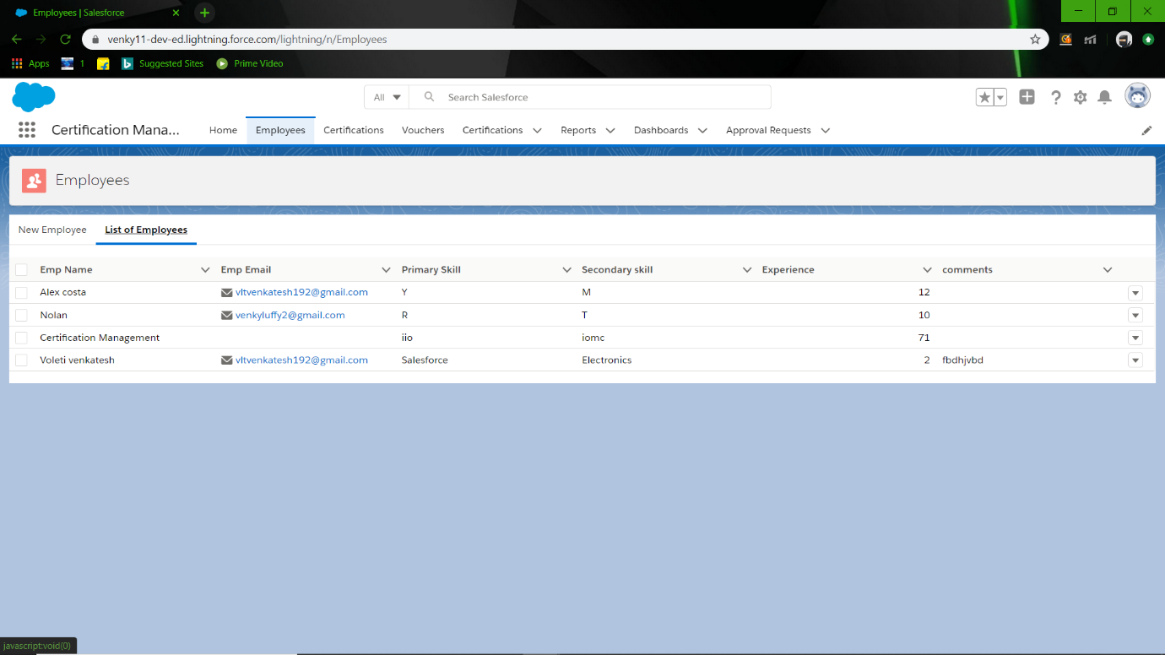

Record Details

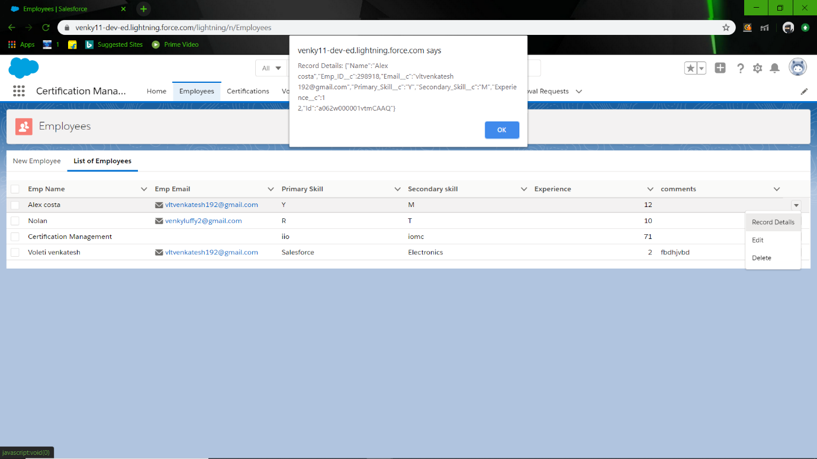

Delete Employee

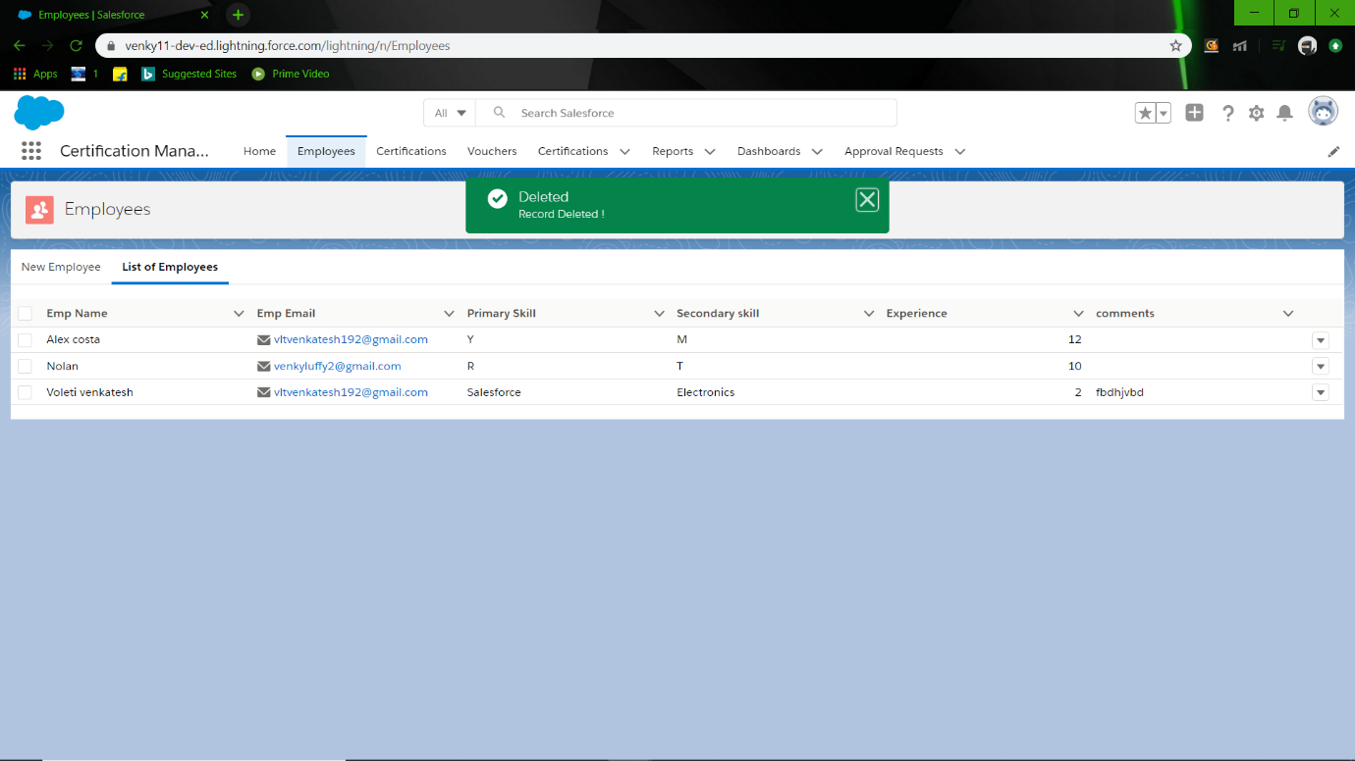

Update Employee

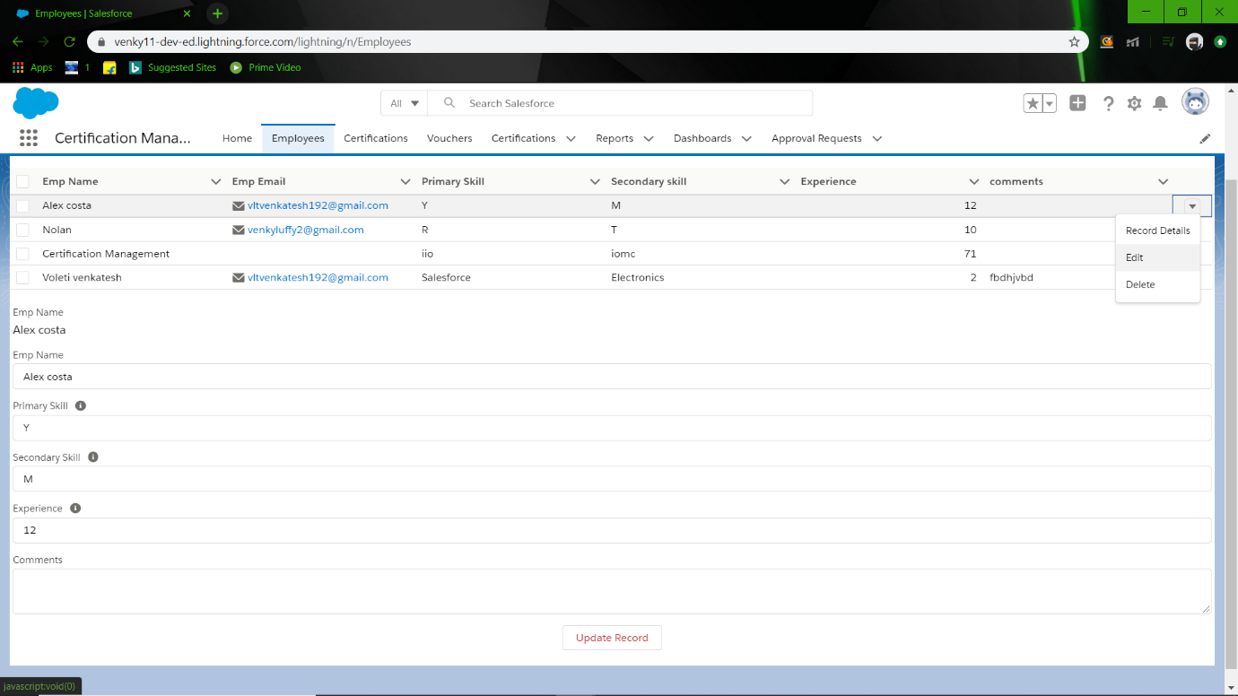

Add Certification

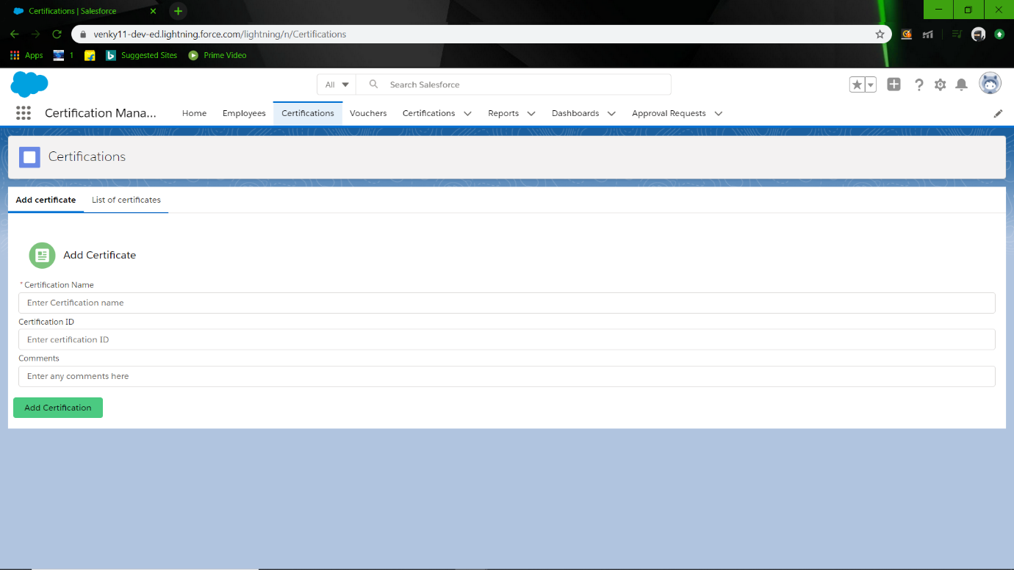

List of Certifications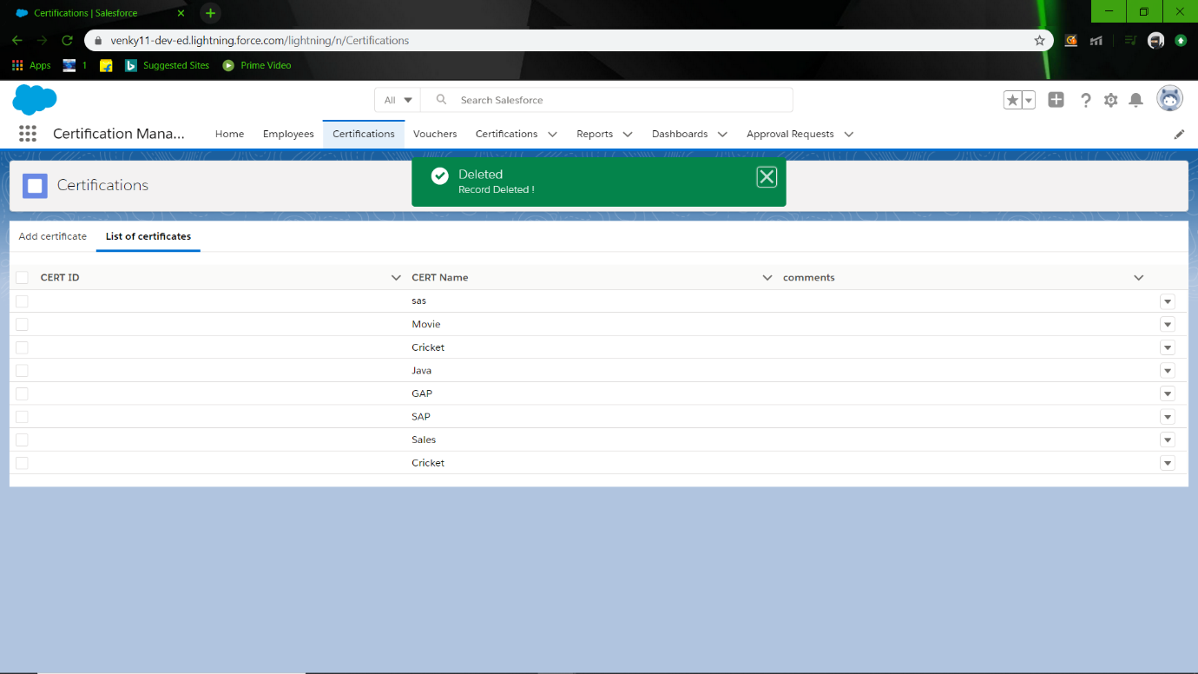

Certification Record Details

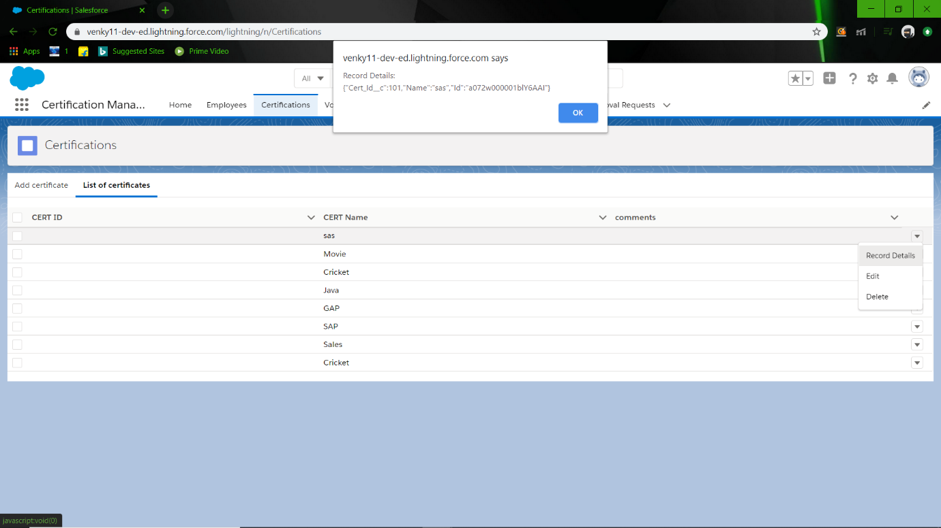

Delete Certification



\Update Certification

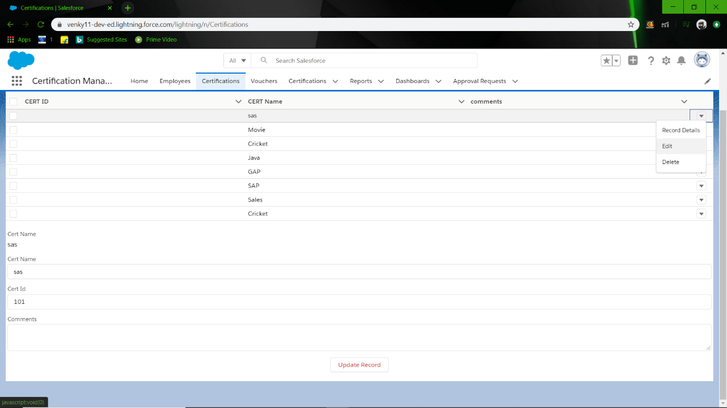

Add Vouchers

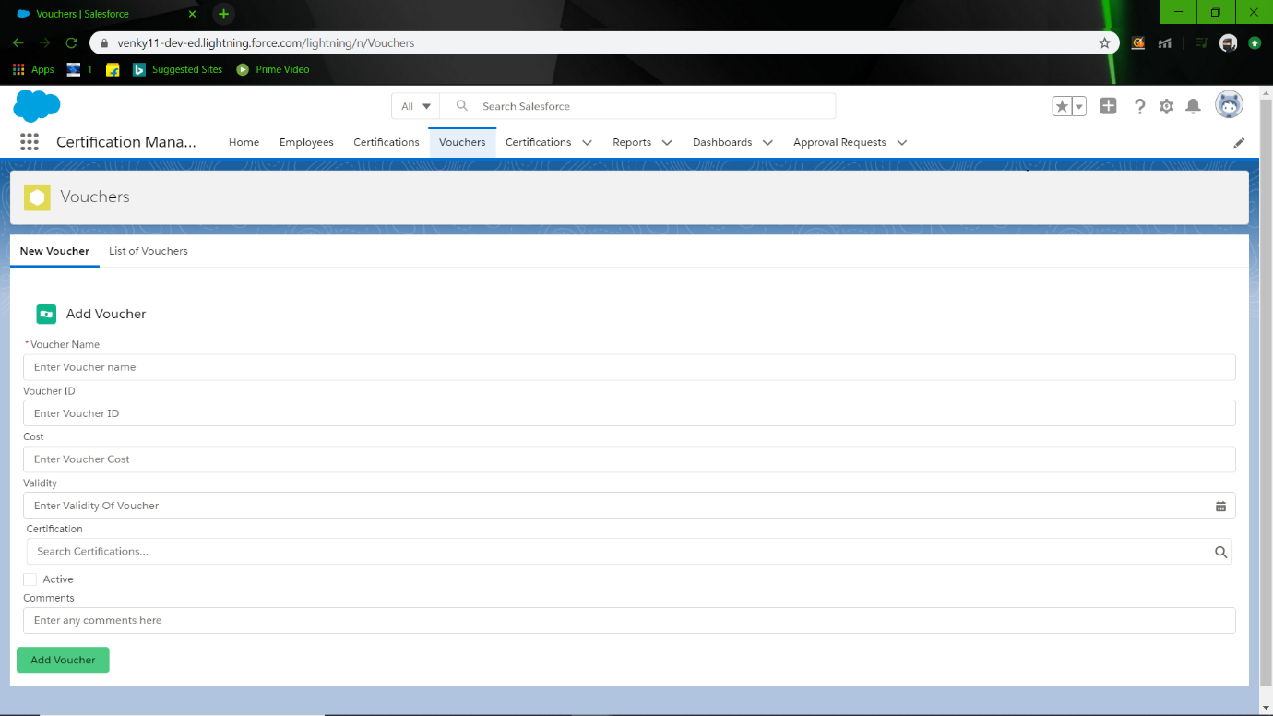

List of Voucher

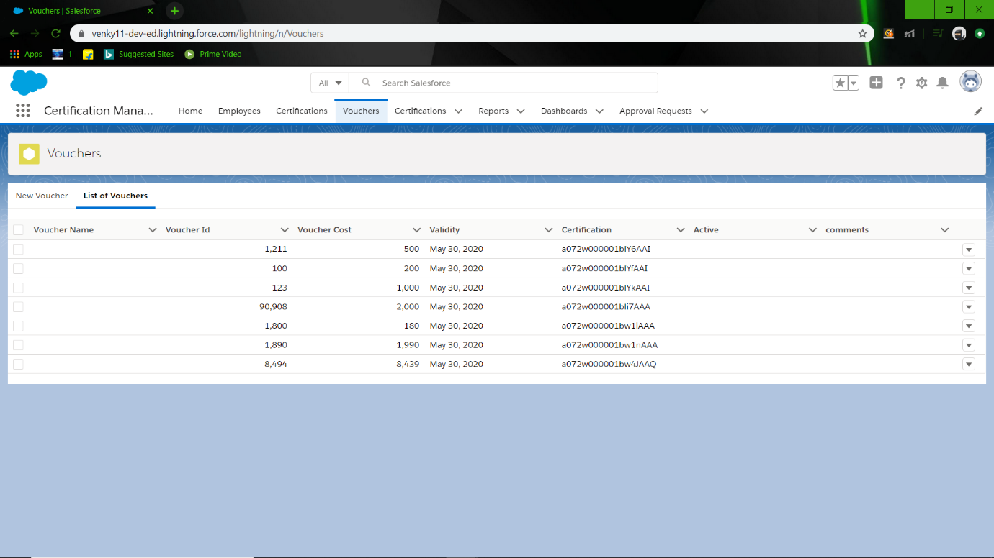

Voucher Record Detail

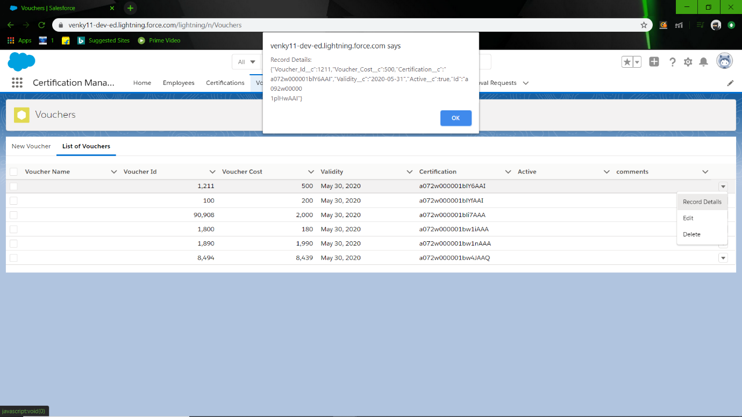

Delete Voucher:

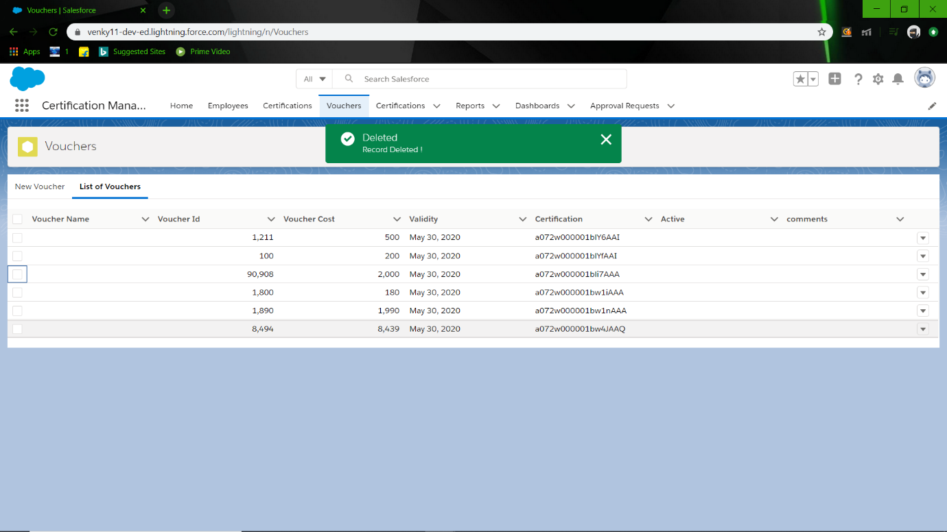

Edit Voucher

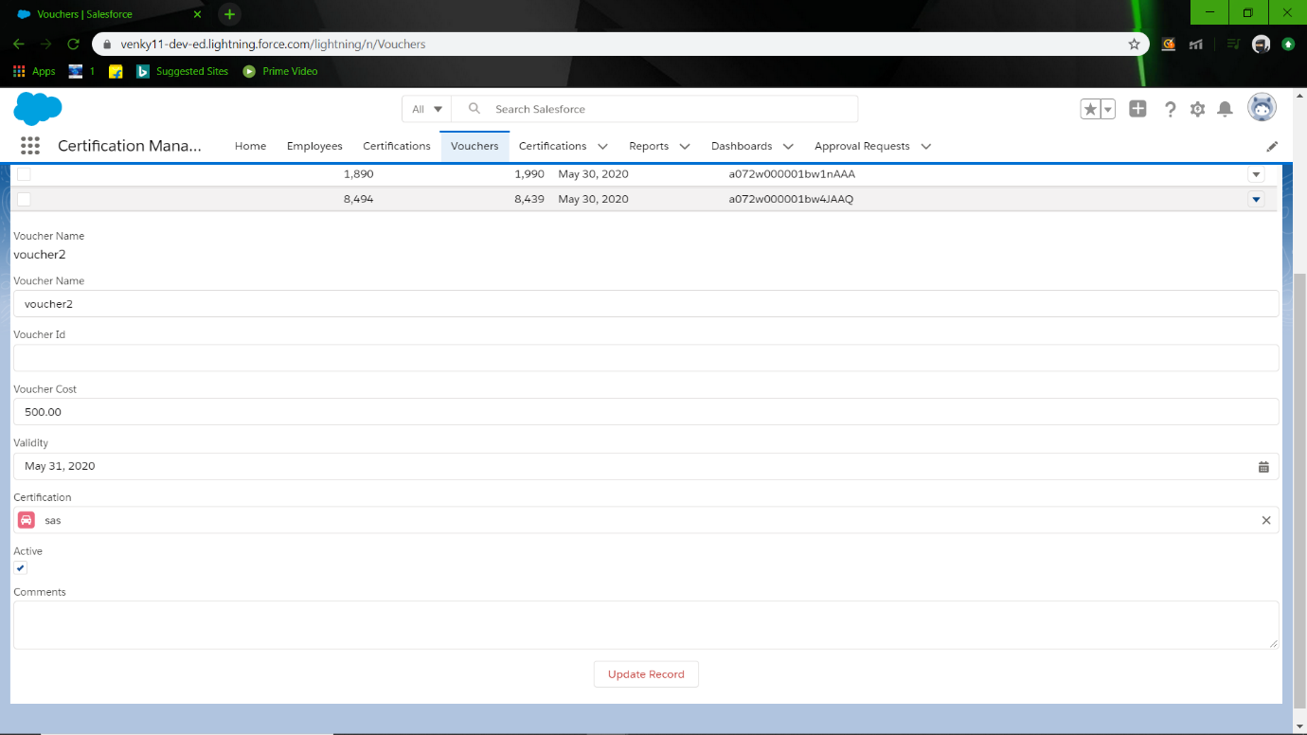

Add Certification request

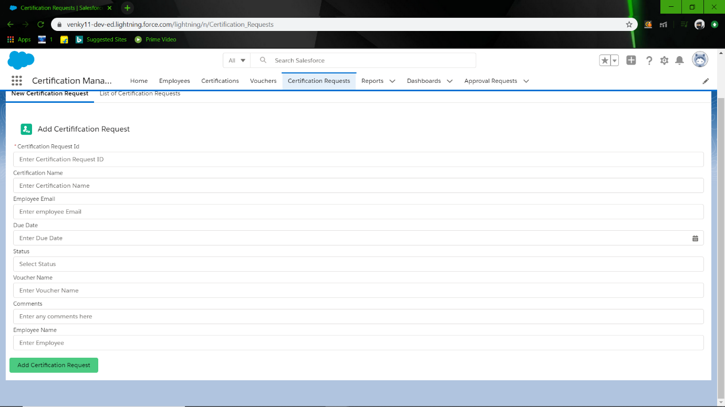

List of Certification request

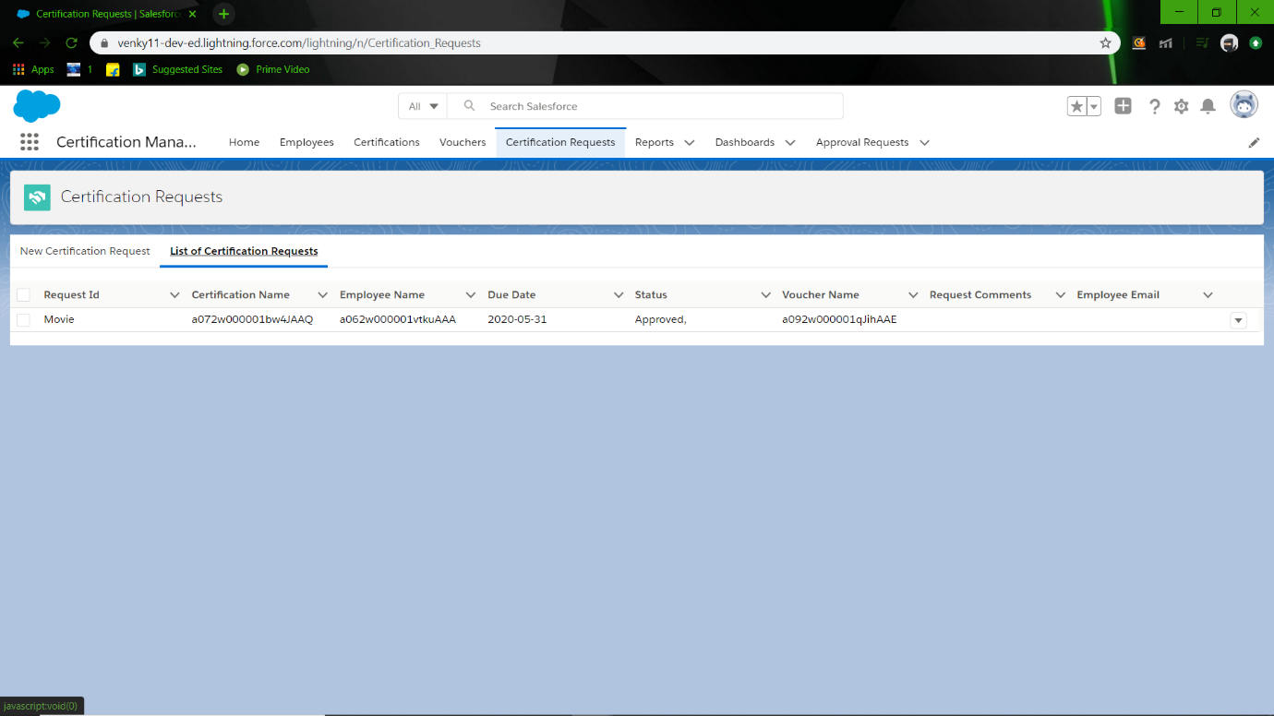

Certification request Record Details

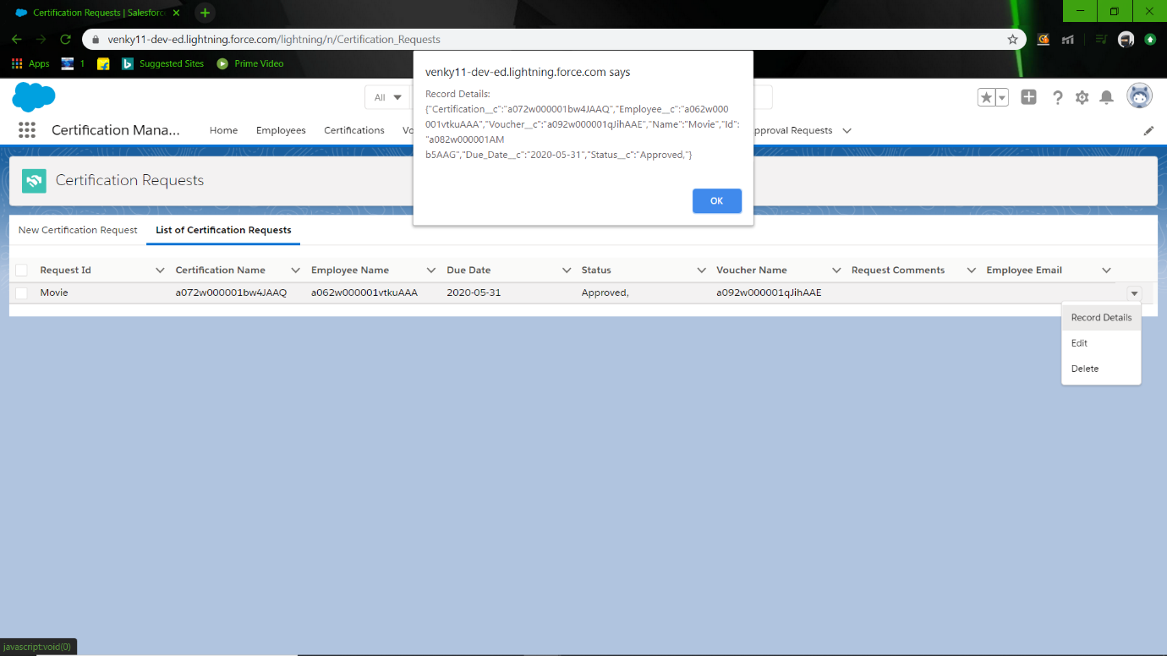

Update Certification request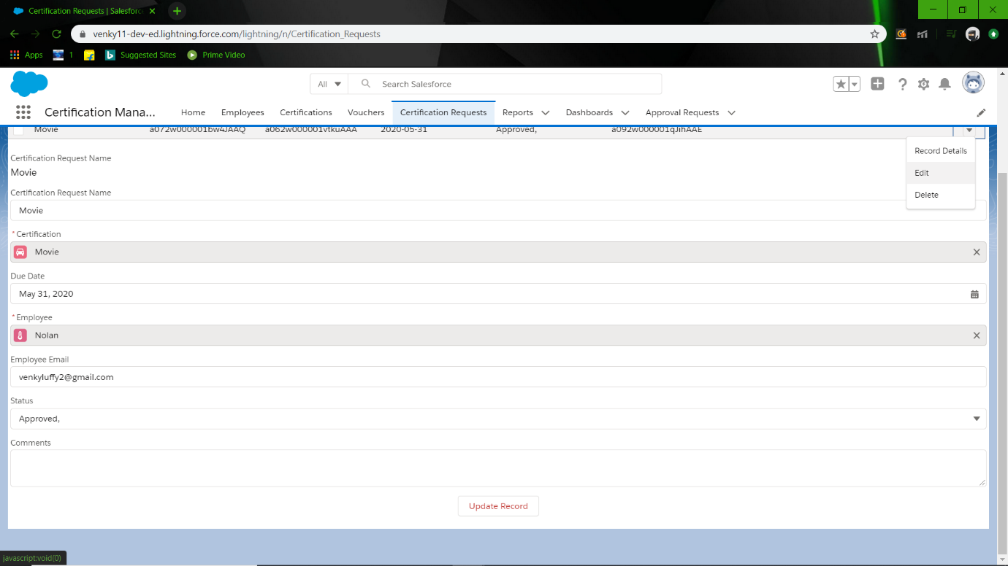

Result:

So, with this I conclude that Certification management App works as mentioned above and includes all use cases mentioned in Problem statement.